**What is the Power Law Distribution?**

The power law (also called the scaling law) states that a relative change in one quantity results in a proportional relative change in another. The simplest example of the law in action is a square; if you double the length of a side (say, from 2 to 4 inches) then the area will quadruple (from 4 to 16 inches squared)

Any inverse relationship like Y = X-1 is also a power law, because a change in one quantity results in a negative change in another.

Example:

The power law can be used to describe a phenomenon where a small number of items is clustered at the top of a distribution (or at the bottom), taking up 95% of the resources. In other words, it implies a small amount of occurrences is common, while larger occurrences are rare. For example, where the distribution of income is concerned, there are very few billionaires; the bulk of the population holds very modest nest eggs

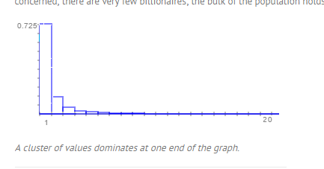

**How to check given RV follows power law distribution:**

If you plot two quantities against each other with [logarithmic](https://www.statisticshowto.datasciencecentral.com/probability-and-statistics/statistics-definitions/logarithms/)axes and they show a linear relationship, this indicates that the two quantities have a power law distribution.

Example: we take Y as probability of density and X as RV.

1. for each Y & X find log.
2. Now plot all log(Y) and log(X) points ie ( log(y1), log(x1) ), ( log(y2), log(x2) ), ……………
3. Now If the resultant plot gives a straight line, then we can say that these two X, Y have power law distribution.

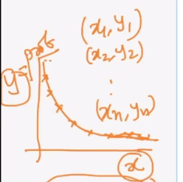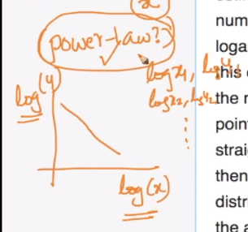

**Pareto Distribution:**

A special type of Power law distribution is the [Pareto Principle](https://www.statisticshowto.datasciencecentral.com/pareto-principle-the-8020-rule/) (also called the Pareto Law), which is an unscientific “law” that states 80% of effects come from 20% of causes. In other words, most of what we do has little effect..

for example, 80% of the wealth of a society is held by 20% of its population

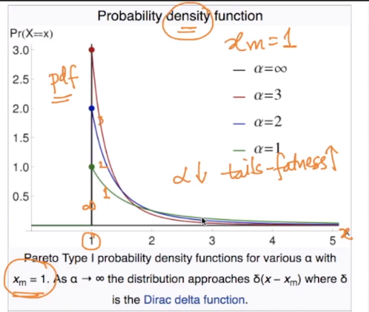

Above figure shows the PDF for Pareto distribution, here

Xm  = 1, and xm is is the smallest value r.v takes.

Alpha is



As alpha decreases the tails fatness increases.